**Seminar on International Humanitarian Law (IHL)**

**Ref No:** PES 18/00447

**Number of Seminars:** 01

**Department:**

* Political Science Department, University of Peshawar

**Speakers:**

* Asma Bangash, Legal Advisor the ICRC
* Waseem Ahmad, Communication Officer the ICRC

**Number of Participants:**

A total of 95 students and faculty members attended the seminar on International Humanitarian Law (IHL) at the Political Science Department of University of Peshawar

**Dates:**  December 07, 2018

**Objectives:**

The objectives of the IHL seminar were:

* To improve the knowledge of IHL among the masses and ensure respect for the law
* To generate the interest of students in conducting research on IHL and topics related to IHL
* To increase awareness about the humanitarian work of the ICRC
* To eradicate misconceptions, if any, about the ICRC

**Background:**

The ICRC`s IHL dissemination program started in 1990`s in Pakistan and has made great progress since then. Currently the ICRC maintains good working relationships with various public sector universities by conducting seminars, certificate courses and dissemination sessions. The collaborations with universities are aimed to enable universities to develop a tradition of teaching and conducting research into IHL so that the potential decision makers can play their roles in its implementation and development.

**Summary and format:**

The IHL seminar was conducted in the Political Science Department of University of Peshawar on December 07, 2018. A total of 95 participants attended the seminar. The Seminar comprised of two sessions each. The first session was about the ICRC and second session was on the comprehensive introduction to IHL. The participants actively and enthusiastically participated in both the sessions and kept the speakers engaged during and after the sessions with questions and a constructive dialogue around IHL.

**Topics Covered:**

The following topics/ aspects were covered in the ICRC session:

1. History of ICRC
2. Mandate & Principles of ICRC
3. Red Cross & Red Crescent (RCRC) Movement
4. Funding & Donors
5. ICRC in Pakistan, and
6. ICRC`s current operations and approach in Pakistan

The following topics were covered in IHL session:

1. Definition of IHL
2. The relationship between IHL and the ICRC
3. IHL and IHRL similarities and differences
4. Purpose of IHL
5. Origin of IHL
6. Geneva Conventions & Additional Protocols
7. Fundamental principles of IHL
8. Case discussions
9. Types of armed conflict and applicable law
10. Implementation and enforcement of IHL

**Conclusion:**

The IHL seminars are a great tool for connecting to masses. They provide a platform for the promotion of IHL and the ICRC`s operations by imparting knowledge of IHL and spreading the information about the ICRC`s work. Such seminars also allow the audience to ask questions and eradicate the misconceptions about the ICRC and IHL and generate a dialogue, thus understanding the essence of the humanitarian law and work.

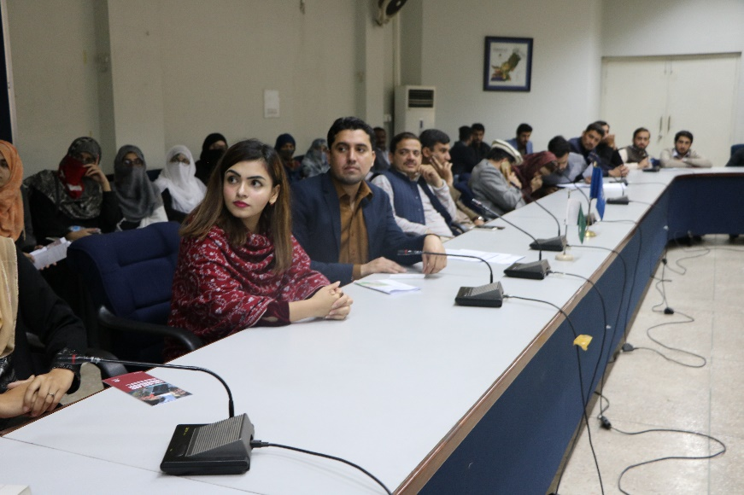**Some glimpses from the seminar:**

